Wireshark Lab 1: IP

Group Details:
Ho Seok Lee (1004112177)
Neehar Kantimahanti (1003872286)

Mark:

 | Question | Answer
1 | Select the first ICMP Echo Request message sent by your computer, and expand the Internet Protocol part of the packet in the packet details window.  What is the IP address of your computer? | 192.168.1.102
Annotated Screenshot (if needed) | 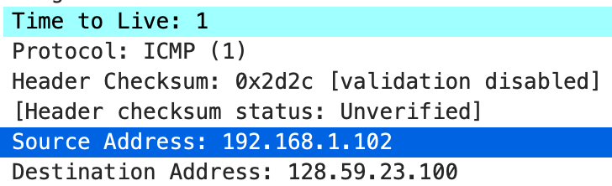
2 | Within the IP packet header, what is the value in the upper layer protocol field? | UDP (17)
Annotated Screenshot (if needed) | 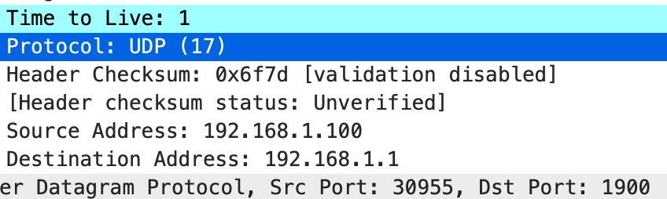
3 | How many bytes are in the IP header? How many bytes are in the payload of the IP datagram? Explain how you determined the number of payload bytes. | There are 20 bytes in the IP header.  Since the total length is 56 bytes, the payload is 36 bytes.
Annotated Screenshot (if needed) | 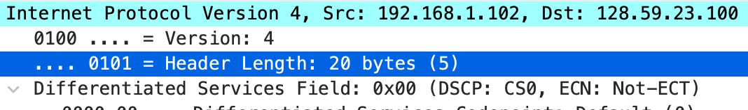  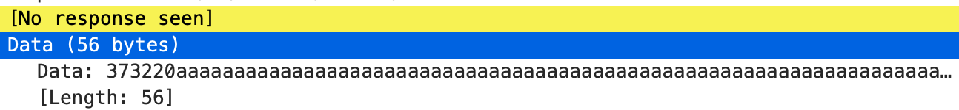
4 | Has this IP datagram been fragmented? Explain how you determined whether or not the datagram has been fragmented. | Since the More fragments bit is not set, the IP datagram has not been fragmented.
Annotated Screenshot (if needed) | 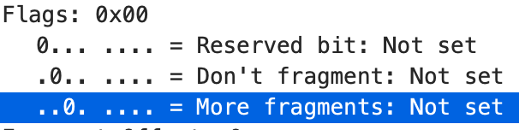
5 | Which fields in the IP datagram always change from one datagram to the next  within this series of ICMP messages sent by your computer? | The three fields Time to Live, Identification, and Header Checksum change from one datagram to the next.
Annotated Screenshot (if needed) | 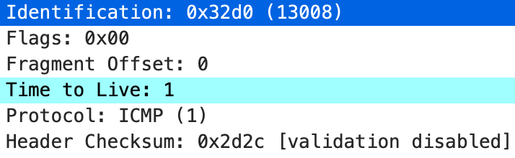  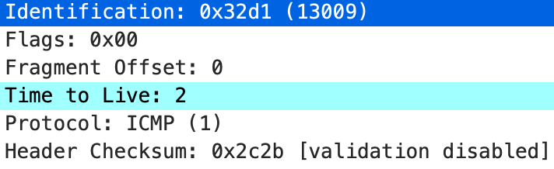
6 | Which fields stay constant? Which of the fields must stay constant? Which fields must change? Why? | The fields that must stay constant (with reasoning) are  - Version (IP version shouldn’t change between datagrams),  - Header Length (UDP packets have consistent header size),  - Source Address (being sent from the same sender),  - Destination Address (being sent to the same receiver), and  - Differentiated Service Field (each datagram is a UDP packet).  The fields that must change (with reasoning) are  - Time to Live (traceroute increase with each packet),  - Identification (different packets should have different ID’s), and  - Header Checksum (due to the two fields changing above, checksum will also change).
Annotated Screenshot (if needed)
7 | Describe the pattern you see in the values in the Identification field of the IP datagram | The Identification field increments by 1 with each IP datagram.
Annotated Screenshot (if needed) | 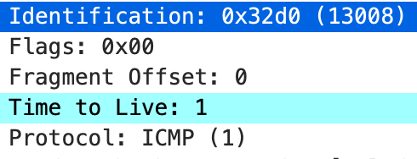  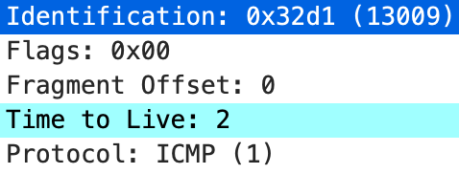
8 | What is the value in the Identification field and the TTL field? | The Identification field is 43507 and the Time to Live field is 244.
Annotated Screenshot (if needed) | 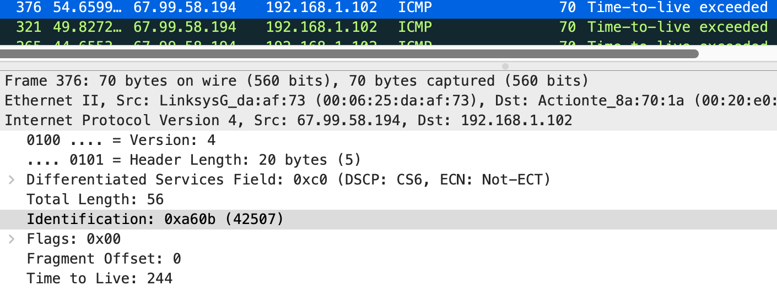
9 | Do these values remain unchanged for all of the ICMP TTL-exceeded replies sent to your computer by the nearest (first hop) router? Why? | Although the Identification field changes, since it is unique to each IP datagram, the TTL field does not change as it is dependent on the router.
Annotated Screenshot (if needed) | 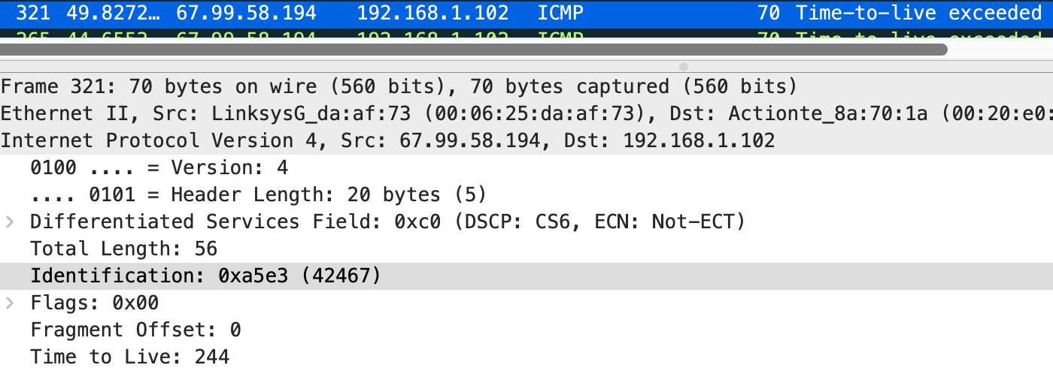
10 | Find the first ICMP Echo Request message that was sent by your computer after you changed the Packet Size in pingplotter to be 2000. Has that message been fragmented across more than one IP datagram? | The message was fragmented across more than one IP datagram.
Annotated Screenshot (if needed) | 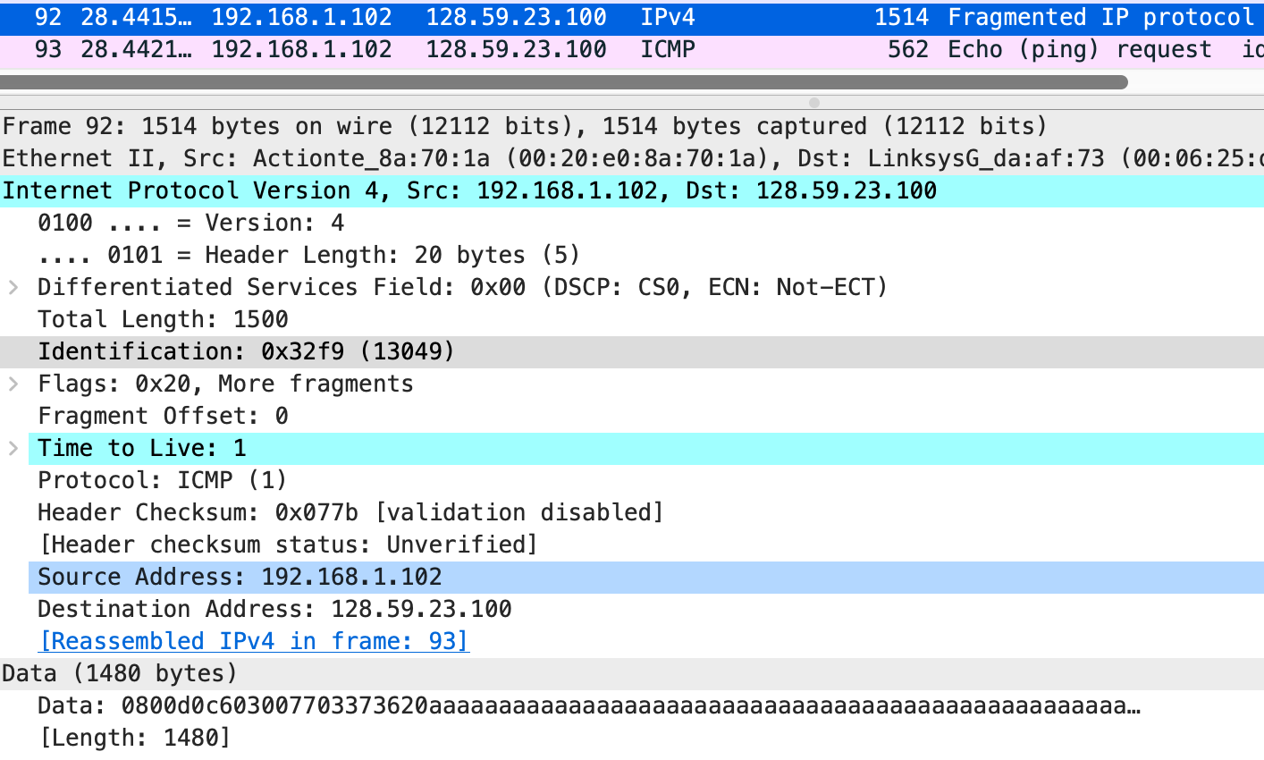  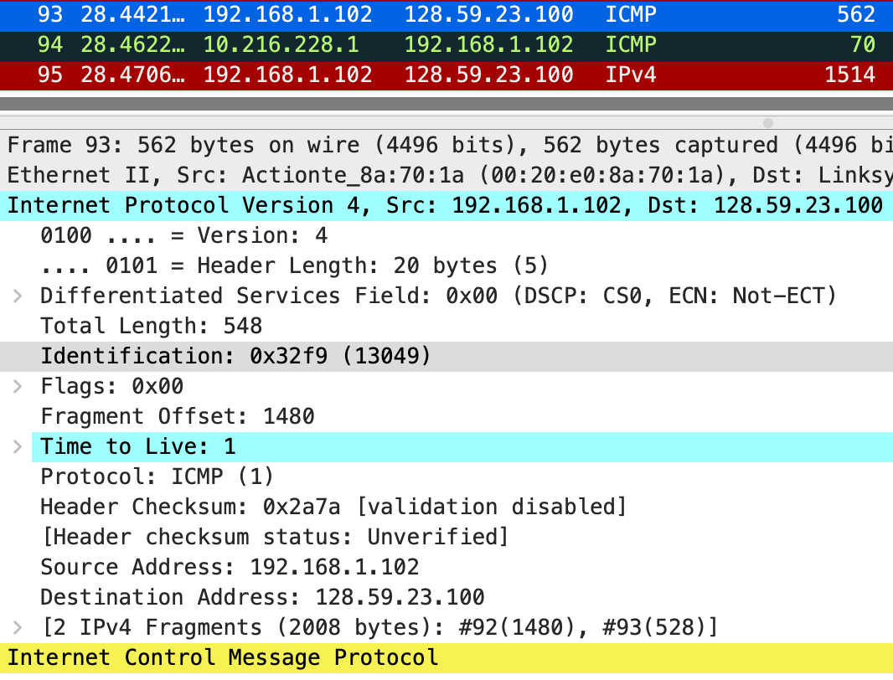
11 | Print out the first fragment of the fragmented IP datagram. What information in the IP header indicates that the datagram been fragmented? What information in the IP header indicates whether this is the first fragment versus a latter fragment?  How long is this IP datagram? | The More fragments flag is set in the IP header, indicating that there are fragments following this datagram.  The Fragment Offset is set to 0 for the first fragment.  This IP datagram is 1500 bytes including the header.
Annotated Screenshot (if needed) | 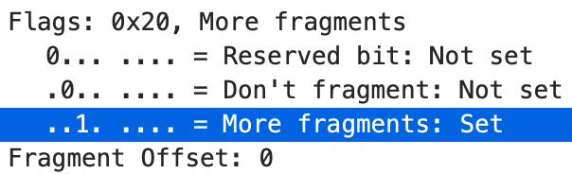
12 | Print out the second fragment of the fragmented IP datagram. What information in the IP header indicates that this is not the first datagram fragment? Are the more  fragments? How can you tell? | The Fragment Offset field is non-zero for fragments that are not the first datagram fragment.  This is the last fragment since the More fragments flag is not set, indicating that there are no fragments following this fragment.
Annotated Screenshot (if needed) | 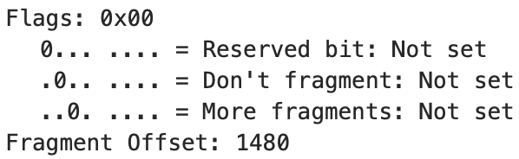
13 | What fields change in the IP header between the first and second fragment? | The fields that change are the Total Length, More fragments flag, Fragment Offset, and Header Checksum field.
Annotated Screenshot (if needed) | 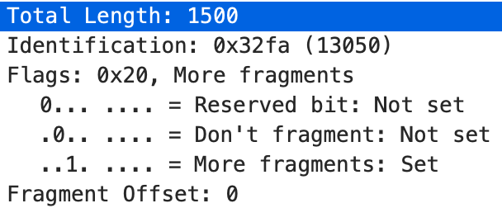  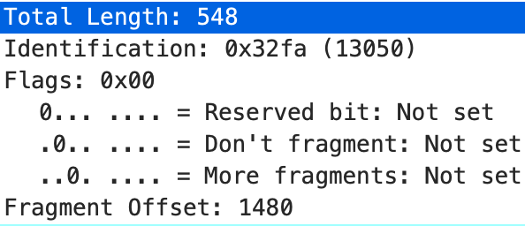
14 | How many fragments were created from the original datagram? | A total of 3 fragments were created from the original.
Annotated Screenshot (if needed)
15 | What fields change in the IP header among the fragments? | The Fragment Offset and Header Checksum field change for all 3 fragments.  Only the More fragments flag and Total Length field change between the second and third fragment.
Annotated Screenshot (if needed)

